CDS – AMDP – Fuzzy Search

1. SAP HANA Studio or Eclipse:  
   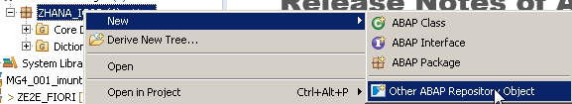  
     
   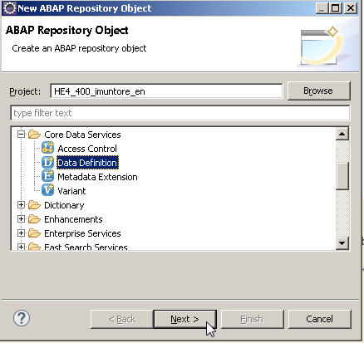

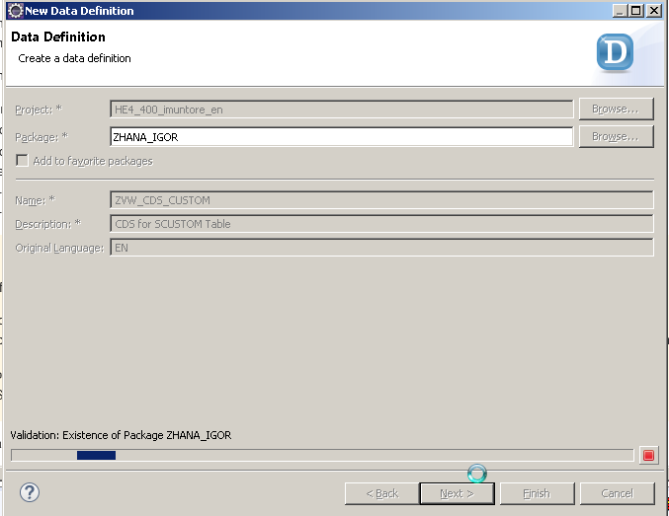

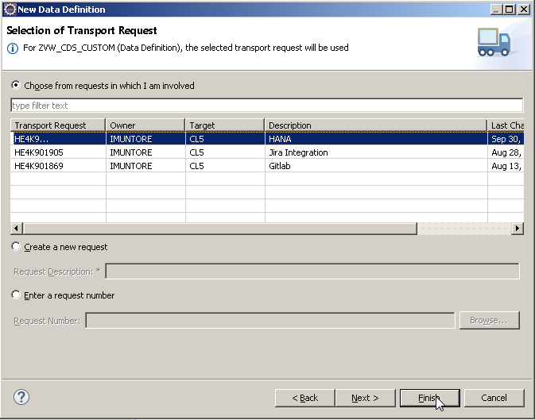

Data Definition Code:

@AbapCatalog.sqlViewName: 'ZVW_CUSTOM'

@AbapCatalog.compiler.compareFilter: true

@AbapCatalog.preserveKey: true

@AccessControl.authorizationCheck: #CHECK

@EndUserText.label: 'CDS for SCUSTOM Table'

**define** **view** ZVW_CDS_CUSTOM **as** **select** **from** scustom **{**

**key** id**,**

name**,**

form**,**

street**,**

postbox**,**

postcode**,**

city**,**

country**,**

region**,**

telephone**,**

custtype**,**

discount**,**

langu**,**

email**,**

webuser

**}**

1. Generate a Class for the AMDP  
     
     
     
     
   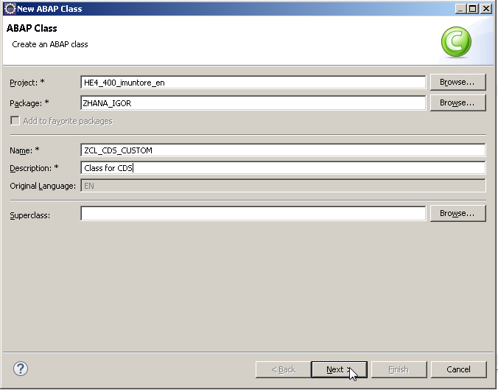

CLASS zcl_cds_custom DEFINITION

PUBLIC

FINAL

CREATE PUBLIC .

PUBLIC SECTION.

TYPES: BEGIN OF ty_scustom,

score TYPE p LENGTH 8 DECIMALS 3,

id TYPE scustom-id,

name TYPE scustom-name,

form TYPE scustom-form,

street TYPE scustom-street,

postbox TYPE scustom-postbox,

postcode TYPE scustom-postcode,

city TYPE scustom-city,

country TYPE scustom-country,

region TYPE scustom-region,

telephone TYPE scustom-telephone,

custtype TYPE scustom-custtype,

discount TYPE scustom-discount,

langu TYPE scustom-langu,

email TYPE scustom-email,

webuser TYPE scustom-webuser,

END OF ty_scustom.

TYPES: tt_scustom TYPE TABLE OF ty_scustom.

INTERFACES: IF_AMDP_MARKER_HDB.

class-METHODS: fuzzy_search importing value(iv_name) type scustom-name

exporting value(et_data) type tt_scustom.

PROTECTED SECTION.

PRIVATE SECTION.

ENDCLASS.

CLASS zcl_cds_custom IMPLEMENTATION.

METHOD fuzzy_search BY DATABASE PROCEDURE FOR HDB LANGUAGE SQLSCRIPT OPTIONS READ-ONLY USING zvw_custom.

* @AbapCatalog.sqlViewName: 'ZVW_CUSTOM'

et_data = select score( ) as score, id,

name,

form,

street,

postbox,

postcode,

city,

country,

region,

telephone,

custtype,

discount,

langu,

email,

webuser

from ZVW_CUSTOM

where contains(name, :iv_name, FUZZY(0.6))

order by score( ) desc;

ENDMETHOD.

ENDCLASS.

1. Test the class trough SE24:  
   